1. Write a Boolean equation in sum-of-products canonical form for the following truth table:

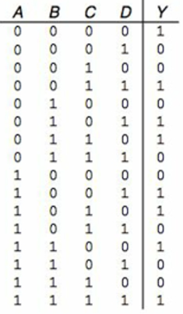

Y = A’B’C’D’ + A’B’CD +A’BC’D+A’BCD’+AB’C’D+AB’CD’+ABC’D’+ABCD

2. Minimize the following SOP Boolean equation using Boolean Algebra:

Y = A’B’ + AB’ + AB

Make sure and show what theorems are being used.

Apply T8 to AB’ + AB -> Y = A’B’ + A(B’+B)

Apply T5’ to B’+B -> Y = A’B’+A(1)

Apply T1 to A (1) -> Y = A’B’ + A

3. Populate the K-map using the following truth.

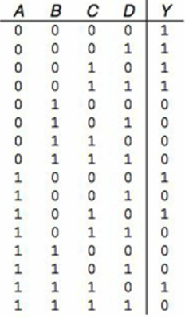

|  |  |  |  |  |  |
| --- | --- | --- | --- | --- | --- |
|  | **CD** |  |  |  |  |
| **AB** |  | **00** | **01** | **11** | **10** |
|  | **00** | **1** | **1** | **1** | **1** |
|  | **01** |  |  |  |  |
|  | **11** |  |  |  | **1** |
|  | **10** | **1** |  |  | **1** |

4. Group the 1’s in the following K-map. Use a different font color or shading for each group.

|  |  |  |  |  |  |
| --- | --- | --- | --- | --- | --- |
|  | **CD** |  |  |  |  |
| **AB** |  | **00** | **01** | **11** | **10** |
|  | **00** | **1** | **1** | **1** | **1** |
|  | **01** |  |  |  |  |
|  | **11** |  |  |  | **1** |
|  | **10** | **1** |  |  | **1** |

5. Determine the product terms for the following K-map groups with an output of Y.

|  |  |  |  |  |  |
| --- | --- | --- | --- | --- | --- |
|  | **CD** |  |  |  |  |
| **AB** |  | **00** | **01** | **11** | **10** |
|  | **00** | **1** | **1** | **1** | **1** |
|  | **01** |  |  |  |  |
|  | **11** |  |  |  | **1** |
|  | **10** | **1** |  |  | **1** |

Gray shade Product Term: C and D change so they can be eliminated. A is 0 and B is 0, so the product term is A’B’

Red Product Term: A and C change so they can be eliminated. B is 0 and D is 0, so the product term is B’D’

Blue shade Product Term: B changes so it can be eliminated. A is 1, C is 1 and D is 0, so the product term is ACD’

Final Equation: Y = A’B’ + B’D’ + ACD’

7. Determine the propagation delay and contamination of the following circuit using the gate delays in the following table:

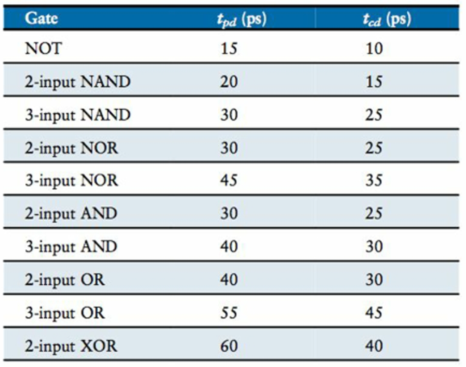

Propagation delay

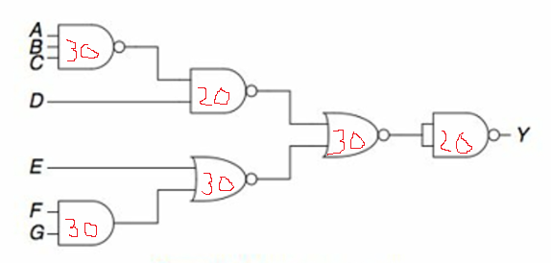

1 2-Input AND * 30 + 2 2-Input XOR * 30 + 1 2-Input XAND * 20 =110

Contamination:

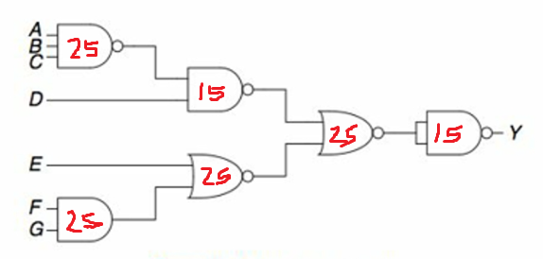

2 2-Input NAND * 15 + 1 2-Input XOR * 25 = 55